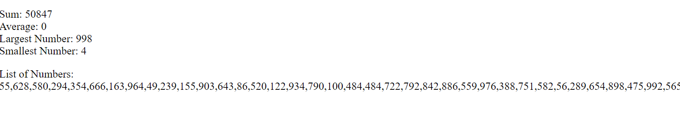

<!--gavin skehan, 21440824-->
<!DOCTYPE html>
<html lang="en">
<head>
<meta charset="UTF-8">
<meta http-equiv="X-UA-Compatible" content="IE=edge">
<meta name="viewport" content="width=device-width, initial-scale=1.0">
<title>Assignment7</title>
<script>
var myArray = [];
var sum = 0;
var average;
var largest = 0;
var smallest = 999;
var average = Math.round(sum / 100);

function nums() {
for (var i = 0;i<100;i++)
{
var randomNumber = Math.floor(Math.random()* 999) + 1;
myArray[i] = randomNumber;

sum += myArray[i];

if (myArray[i] > largest) {
largest = myArray[i];
}
if (myArray[i] < smallest) {
smallest = myArray[i];
}
}

var p1 = document.getElementById("p1");
var p2 = document.getElementById("p2");

p1.innerHTML = "Sum: " + sum + "<br>" + "Average: " + average + "<br>" + "Largest Number: " + largest + "<br>" + "Smallest Number: " + smallest;

var numList = "List of Numbers: ";
for(i=0;i<99; i++) {
numList += myArray[i] + ",";
}
numList += myArray[99] + ".";

p2.innerHTML = numList;
}
</script>
</head>
<body onload="nums()">
<p id="p1"> </p>
<p id="p2"> </p>
</body>
</html>

